Mrs. Keri, Mrs. Brenda, Mrs. Brooke, and
Mrs. Kadee’s Weekly Buzz
January 24-28, 2022
Jan. 24 – CoGAT Testing
Jan. 27 – 100th Day of School!
Jan. 28 – SHARE FRIDAY!
Jan. 29 – Elijah’s Birthday
Feb. 14 – Valentine’s Day

Our Week in Review

WOOHOO WHAT A WILD WEEK!!! We were amazingly smart and finished all of our COGAT testing! We had the best time partying like 100 year olds on the 100th day of school! We had 100 themed snacks, wrote about what we’d do when we’re100, and did much more 100 themed fun activities. Next week we should be back to normal-ish. We sure hope your sweet 100 year old has a great weekend!

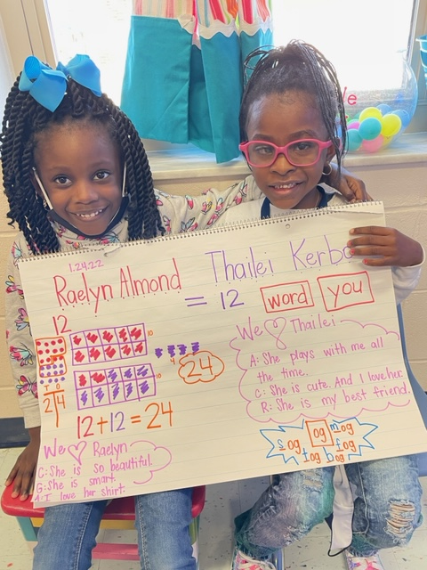
Wish List
- Valentine Cards (to put in our new mailing area)
- Conversation Hearts
- Snacks
This Week’s Sight Words!

word your
Next Week’s Sight Words!

No new words next week. Review old words!

What we’ve been reading…

The Snowy Day
Vocab.: heaping, firm, smacking, packed

Miss Bindergarten Celebrates the 100th Day
Vocab.: delay, create

